UNIFORM ORDER FORM

Uniform Shop hours:
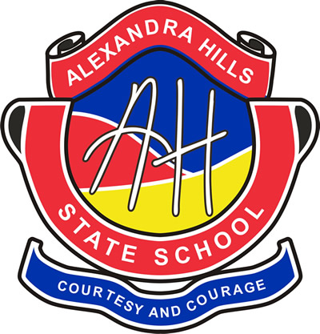
Monday 8:15-9:30am
Thursday 8:15-9:30am
Please circle size required
 | PRICE | QTY | TOTAL PRICE
POLO SHIRT
Size 4 6 8 10 12 14 16 18 20 22 24 | $35.00
BANKSIA SPORT SHIRT
Size 4 6 8 10 12 14 16 18 20 22 24 | $35.00
WATTLE SPORT SHIRT
Size 4 6 8 10 12 14 16 18 20 22 24 | $35.00
SCHOOL DRESS
Size 4 6 8 10 12 14 16 | $50.00
SCHOOL JUMPER
Size 4 6 8 10 12 14 16 | $40.00
SCHOOL HAT
Size SML MED LRG | $15.00
PREP HAT
Size SML MED | $15.00
SHORTS / SKORTS (Circle option)
Size 4 6 8 10 12 14 16 | $20.00
Please contact school if larger size is needed |  | UNIFORM TOTAL | $
Please order your uniforms on this form and enclose cash or pay by card in person, or you can order online on Flexischools!
www.flexischools.com.au
**Prices are subject to change without notice**
---------------------------------------------------------------------------------------------------------------------------------------------------------------------------------------------
Child’s Name: __________________________________________________________________________________
Parent/Carer Name: ______________________________________________________________________________
Email address: _________________________________________ Contact Phone No: _______________________
Payment method: __________________________________

